

**SOUTH EAST REGION**

**BLACK MEMBERS COMMITTEE**

**Regional Black Members Committee Meeting**

**Saturday 24th March 2018**

**10am – 1pm**

**UNISON Guilford Office, Ranger House, Walnut Tree Close, Guilford GU1 4UL**

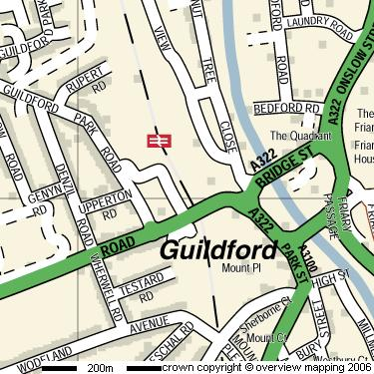

**The SE Regional Black members committee meeting will be held at the UNISON Guilford Office, Ranger House, Walnut Tree Close, Guilford GU1 4UL**

**We have an open hour session between 10am – 11am, which is open to all our black members within the region, where you can network and discuss issues with other members and committee members.**

**From 11am – 1pm, it is our Regional Black Member’s committee meeting.  You are welcome to join this meeting as an observer, but unfortunately you cannot partake in discussions or make decisions.**

**Please note that the times and agenda is kept to a strict timeline. UNISON Guilford Office is right next to Guilford train station.**

**All UNISON Black members in the South East are most welcome to attend.**

**You don’t need to be a steward or a UNISON representative to attend**

**Travel expenses and subsistence will be paid, please keep all receipts.**

**Crèche facilities are available. If you require childcare, please complete the attached form and return by the closing date**

**To attend, please complete the attached registration form and email to c.boorman@unison.co.uk or post to the**

**address on the registration form.**



**APPLICATION FORM**

**UNISON SE Regional Black Members Committee Meeting 24th March 2018**

**Do you require childcare facilities YES / NO**

**If YES your application form MUST reach me no later than Tuesday 6th March 2018.**

**This is so we can request the correct number of childcare personnel for the amount of children that will be attending the event.**

**Please give the child/s: Name & age & all known allergies below;**

______________________________________

______________________________________

________________________________

This form does not need to be approved by your Branch, please forward straight to the SE UNISON Medway Office.

**Please post your completed form to:**

**Clare Boorman**

**UNISON Christchurch House**

**Beaufort Court**

**Sir Thomas Longley Road**

**Strood**

**Kent ME2 4FX**

**Email to: c.boorman@unison.co.uk**

**Fax to: 01634 285714**

**Closing date for crèche places and meeting attendance- Tuesday 6th March 2018**

**Your details**

⬜ Male ⬜ Female

Surname

First name

Membership no.

Branch

Address

Contact number

**Please provide your email address below so we can send you directions, map and the associated paper work for the Meeting:**

Email

**Facilities**

Are you disabled? Yes / No

Do you have any access needs? Yes / No

If you have answered yes to any of the above please give details:

