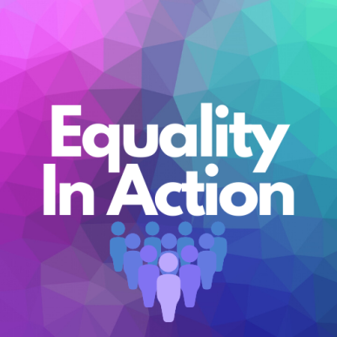
UNISON South East
Equality Conference
ONLINE – 23 April 2021

PROGRAMME

10:00 Welcome, introductions and opening remarks, Jo Galloway, Regional Manager and Regional Head of Equality
10:10 – 11:10
Morning session workshop
Impact of the Pandemic on Working Parents. An examination of the impact on members who have struggled to balance their conflicting responsibilities and how UNISON can help. Facilitated by Vicki Gibbs, Unison SE Area Organiser, Equalities and Education

11:30 – 12:30
Round Table Discussion – What have you learned from the past year? What have been the changes in your working life? Is there anything you would like to take forward once the restrictions are removed? What would you like to change?
Guest Speaker Christina McAnea, UNISON General Secretary

BREAK FOR LUNCH

14:00 – 15:00
Afternoon session workshop
Disabled Members Working from Home and Reasonable Adjustments. To what extent does the Equality Act protect disabled members who are now working from home, and what can UNISON do to support them. Facilitated by Vicki Gibbs, Unison SE Area Organiser, Equalities and Education.

15:30 – 16:30
Panel Event - Poverty, Inequality, and the Pandemic. To what extent has Covid exposed and increased pre-existing inequalities for disadvantaged groups?
Panel Member Guest Speakers:
Peter Kyle, Labour MP for Hove and Portslade. Shadow Minister for Victims and Youth Justice
Gloria Mills, Head of Equality, UNISON.
Josie Irwin, UNISON National Women’s Officer.
16:30 – 16:45
Review, Questions, and Closing Session
Jo Galloway, Regional Manager and Regional Head of
Equality

www.unisonsoutheast.org.uk

