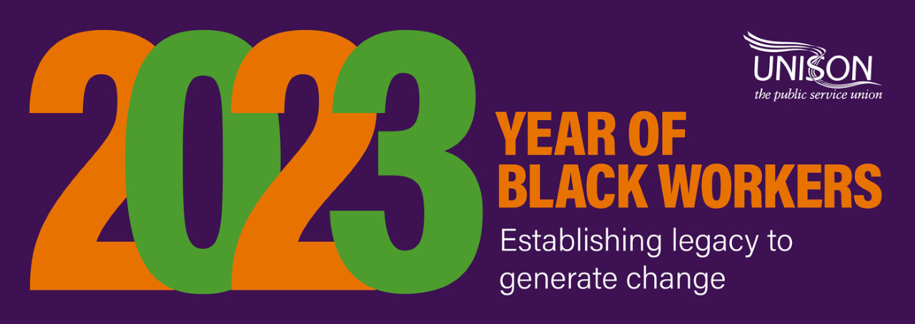

South East Region Black Members Training Passport

10 steps to Empower, Develop and Support Black members
and build Black member activism in UNISON

Black Members Training Passport |  | Tick Preferred attendance
All these courses will be demand driven and courses listed below can be completed in any order: | Tick course/s | Online | In person
 |  |  | Brighton Office | UNISON Centre, London Euston
- Organising Steward (essential)
NB. *if you have already completed this course, you do not need to complete this course again
- Black Member Officers course (including how to set up a Black Members Group in your branch)
- Unconscious Bias
- Breaking Barriers
- Race Protocol
- Confidence skills and Resilience building for Black activists
– strategies to support our Black members to deal with negative behaviours and attitudes as and when they arise. Do’s and don'ts of how to deal with racism, prejudice, and discrimination.
- Next steps to participation
- Race Discrimination
- Mindfulness & Wellbeing
– strategies and techniques to deal with stress and negative behaviours
- Motion writing, speech writing and building confidence in public speaking and understanding conference procedures

The Organising course can be booked here: https://southeast.unison.org.uk/content/uploads/sites/41/2023/04/2023-Education-Program-updated-April-2023.pdf

All courses will be demand driven. Once we have minimum numbers to run each course,
we will contact you with the planned course date and further details.

Please complete the following information and email to: educationse@unison.co.uk

Name
Membership number
Email
Contact number
UNISON Branch
Date

