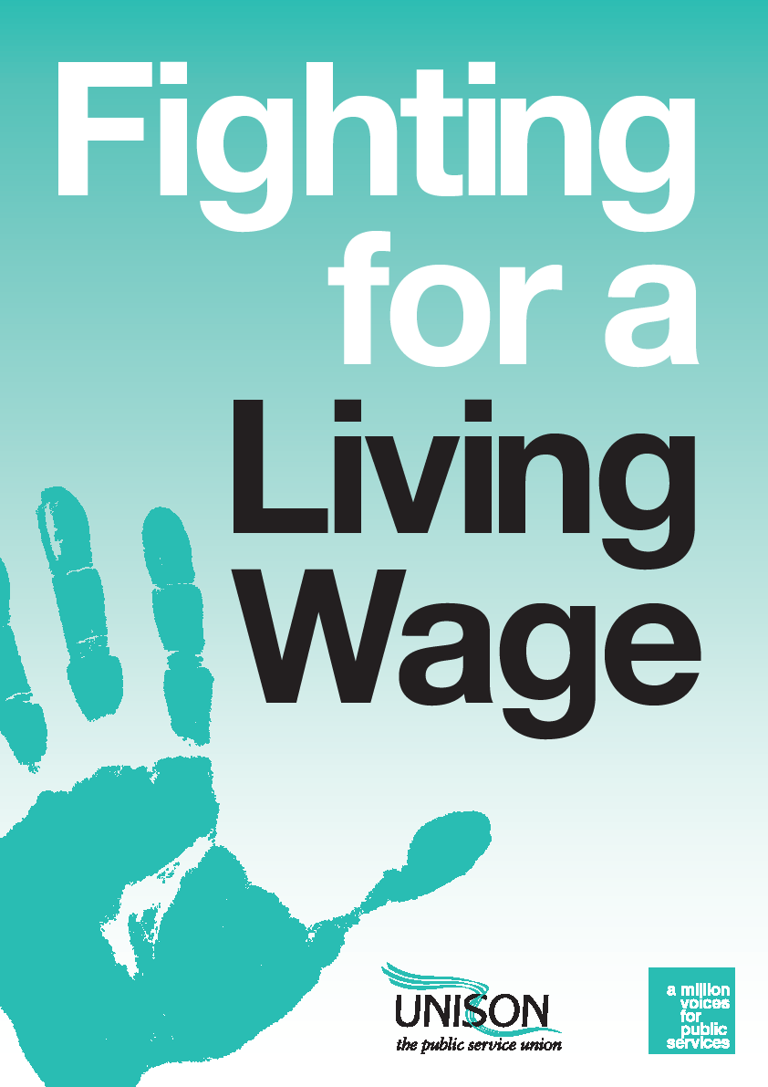

BARGAINING FOR THE LIVING WAGE
Introduction
This guide sets out the key steps in any bargaining strategy for establishing the Living Wage as the minimum rate in an organisation, the campaigning and organising techniques for strengthening that bargaining position and methods of building the Living Wage into procurement policies.
What is the Living Wage?
The Living Wage is an estimate of the minimum hourly rate of pay needed for a worker to cover the costs that most people would regard as necessary for a basic standard of living.
Every November, the Living Wage Foundation announces two new Living Wage rates - one for London and one for the rest of the UK.
The UK rate is calculated by the Centre for Research in Social Policy at Loughborough University and is currently set at £8.25 an hour.
The London Living Wage is calculated by the Greater London Authority economics team and is currently set at £9.40 an hour.
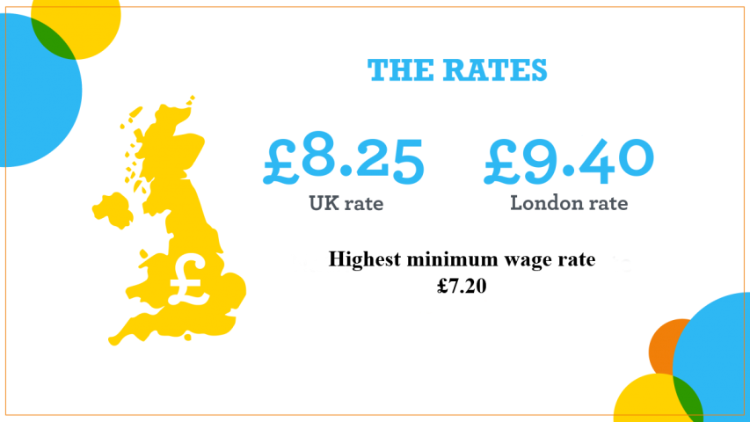
Unlike the legally enforceable National Minimum Wage, whether to pay the Living Wage is a voluntary decision for an employer.
Seeking to bargain minimum pay rates up to the level of the Living Wage is a key part of UNISON’s pay strategy for achieving significant improvements for our lowest paid members against the tough pay bargaining background of dramatic public sector budget cuts.
The Living Wage forms a stepping stone toward UNISON’s wider goal of achieving minimum pay rates of £10 an hour across the UK.
Making the case to an employer
Making the case to an employer for paying the Living Wage inevitably involves a moral argument that none of their employees should be paid less than the minimum rate needed for workers and their families to avoid a life of hardship and that everyone should expect the dignity of a decent standard of living from their work.
However, employers are also liable to be influenced by the economic benefits of paying the Living Wage, which are summarised below:
- Improved recruitment and retention
Employers introducing the London Living Wage have seen a 25% reduction in staff turnover on average.
When introduced by KPMG among its facilities management contract provided by ISS, the policy led to a 40% drop in turnover.
Barclays state that its catering staff retention rate increased from 54% to 77% following the introduction of the Living Wage, and its retention rate for cleaning staff rose from 35% to 92%
Loss of staff carries a heavy financial burden, with the estimated average cost of recruitment now standing at £2,000 per employee, in addition to the time and training necessary to rebuild the skills and experience that are key to providing quality services. KPMG has stated that their spend on hiring was cut so dramatically that they saved £75,000 in the first year of paying the Living Wage.
- Improved productivity and reduced sickness absence
More than 80% of employers that have introduced the London Living Wage believe that it has enhanced the quality of work produced by their staff, while exhaustive studies have shown that increasing the pay of low paid-staff reduces sickness absence rates
- Enhanced reputation among the local community and consumers
Around 70% of employers that have introduced the London Living Wage have reported reputational benefits through increased consumer awareness of their commitment to being an ethical employer. A study in Scotland found that this was one of the most valued benefits for organisations engaged in bidding for public service contracts.
- Enhanced competitiveness
Employers are competing for staff in a labour market where the Living Wage is an increasingly common starting wage. Over 2,300 employers are now accredited as Living Wage employers across the UK, including over a quarter of the largest companies listed on the UK Stock Exchange and household names such as Barclays, HSBC, IKEA and Lidl are among them.
In the public sector, the Living Wage has been established as the minimum pay rate across all public sector organisations in Scotland and it has also been set as the minimum in the NHS throughout Wales. The 2015 pay settlement for police staff in England and Wales set minimum rates above the then prevailing Living Wage, while framework agreements for support staff in more than 12,000 schools across the UK have set the Living Wage as a key target for employers. Across utilities, the Living Wage is paid by SSE, Centrica/British Gas, National Grid and EDF, as well as the water companies Yorkshire, Northumbrian, Dee Valley, Scottish, South East, Sutton and East Surrey.
Even where national agreements have not achieved a Living Wage settlement, a major proportion of individual councils, NHS trusts, universities, schools and academies have taken up the Living Wage following local campaigning. A UNISON Freedom of Information survey covering local government, the NHS, universities, further education colleges and police authorities that drew over 900 responses found that 51% of employers across these sectors already pay at least the Living Wage to their lowest paid staff. The split across sectors is shown below:
Percentage of local employers that pay at least the Living Wage to their lowest paid directly employed staff
Local Government | NHS Trusts | Universities | FE Colleges | 6th Form Colleges
55% | 28% | 70% | 56% | 33%
However, the greatest influence on a local employer can be whether other public sector organisations in their area are paying the Living Wage. For information on whether other public sector organisations in your area pay the Living Wage, contact Bargaining Support on bsg@unison.co.uk
The quotes below reflect the positive experiences of major organisations that have introduced the Living Wage.
Barclays Employee Relations Director Dominic Johnson: “Our UK Living Wage accreditation represents a commitment to ensure that people working on Barclays’ behalf are paid enough to enjoy a decent standard of living. Having supported the Living Wage for over ten years, we know that it can improve productivity, morale and retention rates. This is not just an expression of our corporate values or an issue of social impact, but good business sense”.

Penrose Care managing director Robert Stephenson-Padron: “We incorporated the London Living Wage into our business model from the very beginning. It meant we were going to have a higher cost base than our competitors but we had the firm belief, and this has been confirmed by our success to date, that there would be users of home care services willing to pay a little bit more than average to secure better care workers, with excellent training and high morale, from a provider that genuinely cares for them.”

SSE Director of Sustainability Rachel McEwen: “The business argument for going Living Wage is overwhelming. When SSE was accredited in September 2013 there were only three FTSE 100 companies accredited as Living Wage Employers. While this number is increasing, it is fair to say that the private sector has not been as quick to adopt the policy as the public sector. SSE is happy to be leading the way among publicly-listed companies in introducing the Living Wage.”
PricewaterhouseCoopers infrastructure director Steve Sherwood: “Although our wage bill has increased by £100,000 a year as a result, we’ve noticed staff turnover drop from 4% to 1% and absenteeism reduce as well. The improvements are noticeable: we have a more stable and happier workforce. And because our organisation now has a reputation for being a good place to work, we attract better people.”

Responding to the employer
The employer says they can’t afford it
The most likely reason an employer will put forward for resisting the Living Wage is affordability. To counter those arguments it’s necessary to collect information on the size of the workforce affected, the cost implications of increasing their rate to the Living Wage and the scale of surpluses produced by the organisation.
Illustration of the case that can be built from accounts
In 2015, the support service company Interserve recorded an operating profit of £73m (up 30% on 2014) on sales of £3.6bn and handed out £34m to shareholders in dividends (up 7% on 2014). The chief executive received remuneration worth £1.5m, which is 94 times the value of the Living Wage for a full-time employee on 37 hours a week.
The first option for gathering information on the number of staff paid below the Living Wage and their wage levels is a simple request to the employer and where UNISON is recognised for collective bargaining by the employer, the general duty to disclose information on pay and benefits in line with the ACAS code on disclosure of information to trade unions for collective bargaining purposes is a useful tool. However, Freedom of Information (FoI) requests offer an alternative in the public sector where an employer is obstructive and require a response to be provided within 20 working days. For advice on how to lodge a FoI request, see the UNISON FoI web page
The costs of the Living Wage have to be set against the financial performance of the employer. Public sector bodies will normally publish their annual accounts on the web. In the case of private contractors, accounts have to be registered with Companies House and charities must register their accounts with the Charity Commission. If you require any assistance in obtaining or interpreting accounts, please contact Bargaining Support on bsg@unison.co.uk.
In addition to profit and loss figures, accounts will also frequently highlight the pay of chief executives or other leading figures in an organisation, providing valuable data to contrast against the income of low-paid staff [In local government, as part of the Localism Act 2011, local authorities in England have to publish an annual pay statement showing the highest and lowest paid employees. This can be found on authorities’ websites.]
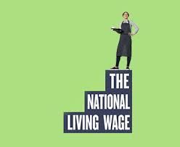
The employer says they already pay the “national living wage”
In April 2016, a new National Minimum Wage rate, labelled by the government as the “national living wage,” came into force for workers aged over 24.
This rate should not be confused with the real Living Wage announced annually by the Living Wage Foundation.
The government’s rate is worked out very differently to the real Living Wage. Most importantly, the government’s rate fails to properly take account of the cost of living. If the price of food, electricity bills, mortgage payments or rents go up, the government’s calculation of the wage doesn’t change in line with those costs.
In contrast, the real Living Wage is calculated by a rigorous formula that takes account of the real changes in the costs that workers face.
Consequently, the current “national living wage” rate of £7.20 is more than a pound an hour less than the UK Living Wage, which translates into a salary in excess of £2,000 lower for an average full-time worker on a 37-hour week.
In addition the government’s “national living wage” only applies to staff aged over 24. The National Minimum Wage for workers aged between 21 and 24 remains at £6.70 an hour, for 18 to 20 year olds it stands at £5.30, for under 18s it’s £3.87 and for apprentices it’s £3.30. In contrast, the real Living Wage applies to all workers over the age of 18 and therefore treats a much larger section of the workforce as equally deserving of a decent income.

Bargaining strategy decisions
Pushing for accreditation
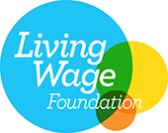
The preferred method of adopting the Living Wage is for an employer to obtain official accreditation through the Living Wage Foundation. The foundation sets out the procedure to be followed at http://www.livingwage.org.uk/how-become-living-wage-employer [For Scotland, the accreditation process is summarised here]
The principal advantage to the employer of accreditation is that it allows the organisation to generate greater publicity and recognition of its status, utilise the Living Wage Employer Mark and work with the foundation on positive press coverage.
For employees, accreditation ensures that the organisation is committed to meeting the annual increase in the Living Wage rate by 1 May every year and the wage is ultimately applied to contracted out workers as well as directly employed staff. If the employer is unable to enforce the Living Wage among all its contractors immediately, it has to commit to a timetable of applying the Living Wage as contracts come up for renewal.
The foundation contacts the employer quarterly to ensure that pledged milestones have been achieved and while there is no absolute time limit, the foundation expects the bulk of contracts to move onto the Living Wage within two to three years.
If there is reason to believe that the implementation plan is not being met and if no satisfactory solution can be reached through discussions with employer, the Living Wage Foundation can be contacted to investigate via http://www.livingwage.org.uk/contact-us-non-payment
Living Wage Service Provider status
In addition to full Living Wage accreditation, the foundation offers Living Wage Service Provider status. Under this classification, the employer commits to paying all their head office staff the Living Wage, but they also commit to supplying a Living Wage bid alongside every market rate bid to all of their prospective and current clients. This classification is targeted on contractors and the employers that have signed up overwhelmingly operate in the facilities management fields of catering and cleaning, such as Cofely GDF Suez, ISS Facility Services, OCS Group and Sodexo.
The foundation sets out the process at http://www.livingwage.org.uk/how-become-recognised-living-wage-service-provider
However, most Living Wage employers in the public sector have not gone down the route of official accreditation, but have simply applied the Living Wage to their directly employed staff and made annual decisions about whether to uprate to the new Living Wage figures or not. This is reflected in the fact that UNISON’s Freedom of Information survey in 2015 revealed that only 11% of public sector employers have a commitment from their contractors to pay the Living Wage.
The maximum benefit to all members is obtained by obtaining full accreditation, particularly as contracted out staff frequently contain a high proportion of staff paid below the Living Wage. However, local circumstances may influence whether the best strategy is to go for full accreditation straight away or whether it is better to establish the principle of a Living Wage as a stepping stone to widening its scope at a later stage.
Cascading benefits up the pay scale
Introduction of the Living Wage will usually mean a cascade effect on pay points higher up the pay scale to maintain reasonable gaps between pay points that recognise the different levels of skill and experience required for different roles and offer sufficient incentives to take on greater responsibilities.
How far to push these increases can be influenced by the cost and local judgement about how that may impact on the employer’s willingness to accept the principal of a Living Wage.
Maintaining pay scale equality
Failure to ensure pay rates are aligned with work of equal value opens up any pay scale to equal pay challenges. Generally, the introduction of a Living Wage makes a positive contribution to tackling pay inequalities, but negotiators should be vigilant that the Living Wage does not undermine pay structures which have been designed to deliver equal pay or compromise equal pay agreements, such as Single Status or Agenda for Change.
Co-ordination across the union
UNISON negotiators seeking to deliver a Living Wage should be mindful of all applicable national/sector wide agreements, including those on pay. The Living Wage should be seen as a supplement to national agreements, not a replacement for them.
It is also important to take into account bargaining arrangements covering more than one region, such as those covering large private companies. To ensure this happens, organising around the Living Wage in the private or community and voluntary sector, should be undertaken in consultation with the Head of Business, Community and Environment - BusinessCommunity-EnvironmentUnit@unison.co.uk
In local government, UNISON’s Ethical Care Charter includes payment of the Living Wage for home care workers as a key final step in the process of becoming an Ethical Care Council. For information on how the Living Wage can be achieved as part of a charter campaign, click here
Branches should advise their region, service group and/or UNISON Bargaining Support where Living Wage negotiations are successful.
Resisting local living wages
The Living Wage rates announced annually by the Living Wage Foundation are rigorously calculated on the basis of data from widely used and trusted sources. Therefore, UNISON is resistant to the development of local “living wages” which would have the potential to fragment the Living Wage campaign into a myriad of different rates.

Campaigning strategy
UNISON’s general advice on campaigning can be found at https://www.unison.org.uk/content/uploads/2013/06/On-line-Catalogue193083.pdf
This guide includes an 11-step process, which covers planning of the campaign, building alliances, engaging with members, attracting media publicity, lobbying decision makers and accessing resources.
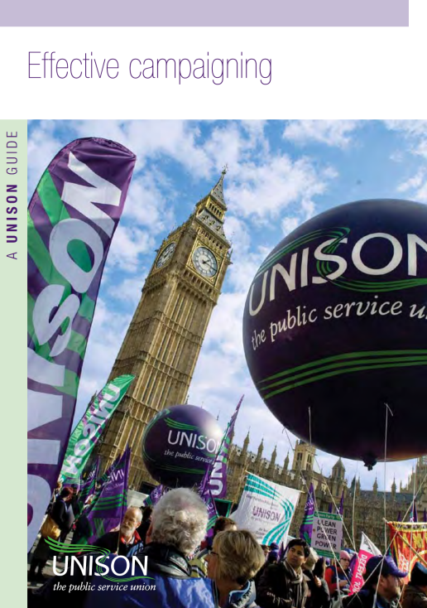
Many of the features of a Living Wage campaign will be in line with this general advice, but the main features specific to mounting a drive for the Living Wage are set out below.
- Many groups in the local community will share the goal of maintaining high quality public services and ending poverty wages. Other trade unions, trades councils, local politicians, service users, professional bodies, community organisations, student unions, faith groups and local media are all possible allies in building a broad-based community coalition.
- Engagement with allies is best initiated directly. Don’t be tempted to send them a leaflet or an email and expect them to get involved. It is worth putting in the time to meet with key people face to face. Find out as much as you can about their concerns and issues. They will be more likely to join the coalition if they feel that their issues will get support in return.
- Consider inviting key leaders to join a working group that will co-ordinate the campaign. Think about holding a larger community meeting that will bring all supporting groups together in a public way. Encourage allies to consider how they can use their existing community links to widen the campaign further.
- Poverty pay is an emotive issue, so the opportunities for gaining local media attention should be strong, particularly if it is possible to provide journalists with personal stories that show what low pay means to members and their families.
- Consider which organisation(s) should form the main target of your campaign. In the case of a contractor, it may be as important to target the commissioning body as the direct employer, since the commissioning body determines the budget available for payment of the Living Wage.
- UNISON firmly believes that a Living Wage will almost always lead to a net benefit for low paid workers and that state benefits are not a substitute for reasonable wages. However, it is important to make members are aware that in some circumstances, means tested benefits can fall as wages rise.
Publicity materials for a Living Wage campaign are available on the UNISON Living Wage page here
Click on the “Resources” link to access the ordering form for:
- Living Wage posters
- Living Wage placards
- Living Wage stickers
The Resources page also enables you to download:
- Living Wage social media graphs
- A briefing to assist in explaining of the difference between the real Living Wage and the government’s “national living wage”
- A Living Wage template for developing your own campaigning material
- Implementation plans for Church of England and Catholic schools

Building the Living Wage into contracting out
A Living Wage campaign can lock in a long term strategy for dealing with contractors by working with the employer on a procurement policy that includes the Living Wage as a factor for consideration in the tendering process.
UNISON’s model organisational change policy shows how the Living Wage can be included as part of a set of “fair work practices” that any contractor has to outline its position on as part of submitting a tender. The contractor’s position is then considered as part of the selection process for awarding the contract.
Public sector employers have taken a variety of approaches to inserting Living Wage considerations into contract notices when services are put out for tender. The tables below set out actual examples of Official Journal of the European Union (OJEU) contract notices that may provide useful models when negotiating with employers over the terms of contracts issued.
The set of five examples below show how some employers have taken a very direct approach to specification of Living Wage payments.

Contract: Cambridge City Council – Security services
Section of OJEU notice: Section VI Complementary information / Additional information
Statement: “The Council pays its own staff at least the Living Wage and has adopted a policy which means that any contract let as a result of this competition will contain a contract condition which will require the appointed contractor to pay at least the Living Wage to all staff (whether directly employed or sub-contracted) that work on the Council’s premises/ land delivering services for more than 2 hours a day in any given day in a week for 8 or more consecutive weeks in a year and the contractor must ensure that a provision is included in any sub-contract to satisfy this requirement.”
Contract: London Borough of Camden – Architectural, construction, engineering and inspection services
Section of OJEU notice: Section VI Complementary information / Additional information
Statement: “Bidders need to be aware that, should they be short-listed, they will be asked to propose solutions to deliver the social, economic and environmental benefits specified in the Invitation to Tender and to pay the National or London Living Wage to employees including their sub-contractors working on LB Camden contracts in accordance with the criteria set by the Living Wage Foundation.”
Contract: Ipswich Borough Council – Cleaning services
Section of OJEU notice: Section III Legal, economic, financial and technical information / Other particular conditions
Statement: “The performance of the contract is subject to particular conditions: yes
Description of particular conditions: The council considers that the Transfer of Undertakings (Protection of Employment) Regulations (TUPE) will apply to employees of the existing contractor regarding Lot 1 and to employees of the council for Lot 2. Ipswich Borough Council requires all its contractors to pay a ‘Living Wage’ as defined by the Living Wage Foundation to all those employed on the contract.”
Contract: City of York Council – Health services
Section of OJEU notice: Section VI Complementary information / Additional information
Statement: “City of York Council have included within the Invitation to tender documents the requirement for bidders to comply with offering the Living Wage to their employees who receive the minimum wage who would be directly employed in the delivery of the Integrated Sexual Health Service in order to be considered for this contract.”

Contract: University of Huddersfield – Supply services of personnel including temporary staff
Section of OJEU notice: Section III: Legal, economic, financial and technical information / Economic and financial ability
Statement: “Bidders will be required to conform to the Universities HR policies one of which is payment of the UK Living Wage as a minimum to all staff employed or providing a service on campus.”
Where an employer may be reluctant to follow these examples, the set of four examples below may be useful as they at least set out a commitment to the general principle of a Living Wage or require submission of a variety of bids, one of which has to be based on payment of the Living Wage.
Contract: Ashfield District Council – Refurbishment work
Section of OJEU notice: Section VI Complementary information / Additional information
Statement: “The Contracting Authority and its agent, AHL, promote the concept and the ethos of the ‘Living Wage’ (or its member state equivalent where relevant), whereby all workers should, as a minimum, be paid at a level which enables them to achieve an acceptable standard of living. Whilst this is not a prerequisite or mandatory requirement for organisations that work on the behalf of the Contracting Authority or its agent, the Contracting Authority would anticipate that tendering organisations would share its commitment to this principle, and organisations expressing interest should expect the tender documents to reflect the Contracting Authority’s aspirations in this regard.”
Contract: Brighton and Hove City Council – Sports facilities operation services
Section of OJEU notice: Section II Object of the contract / Total quantity or scope
Statement: “The Council would like to invite qualified suppliers to respond to this ITT for the provision of management services for Portslade Sports Centre. Suppliers must provide 2 bids — the first being a base bid with the suppliers bid based on best price and the second bid, a mandatory variant bid (identical to the base bid) except that the bid will be based on providing Living Wage for all staff.”
Contract: London Borough of Lewisham – School-meal services
Section of OJEU notice: Section II Object of the contract / Total quantity or scope
Statement: “The London Borough of Lewisham is inviting providers to tender for the School Meals Service in Lewisham. The Contract will be issued for a period of 5 years with the option to extend for up to 2 years at the Council’s discretion. Variant Bids As part of this procurement, the Council is requesting the presentation of variant elements of the bids in addition to completion of the core business proposals. 1) London Living Wage 2) Food For Life Gold Accreditation 3) Supply of Utilities Meters 4) Extension of UFSM to KS2 5) Contracting Period 6) Free Children’s Breakfast 8) Alternative Labour Structure.
Contract: University College London – Cleaning services
Section of OJEU notice: Section II Object of the contract / Short description of the contract or purchase(s)
Statement: “UCLU will give preferential consideration to contractors paying employees the London Living Wage”
In the absence of any agreement to include the Living Wage as a factor for consideration in the tendering process, it is of value to check whether any of the contractors submitting a bid are among the Living Wage Foundation's listing of Living Wage Service Providers on this link http://www.livingwage.org.uk/service-providers These organisations have committed to providing a quote based on paying the Living Wage so that the commissioning body can make an informed choice.

Organising around the Living Wage
- Constructing a claim:- Consult workers on developing a Living Wage campaign. Good practice is to start with an open meeting for members and non-members where the workforce is briefed about the current situation and potential improvements. The decisions about the details of the claim that should be put to the employers should then be made in a meeting open to members only.
- Mobilising the membership:- Members and non members need to see that the union has been instrumental in achieving the claim. Members should be asked to support the claim by, for instance, signing a petition, wearing a badge or taking some other action. In this way, workers are empowered by showing that they can change things through joining together in the union, rather than simply being recipients of services.
- Recognising wins:- Too often we undermine our achievements and fail to point out that, without UNISON and more importantly our members, any improvements would not have been won.
For more advice on organising issues see UNISON’s Organising Space

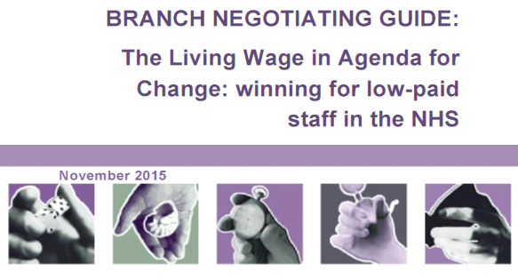  For specific advice on negotiating for the Living Wage in the NHS, click here |  | For branches representing members in the water industry, click here to see how you can support the Making Waves for the Living Wage campaign

Appendix - Suggested letter to employer on the Living Wage

Dear
[Insert name of employer] seeks to be a good, fair, equal opportunity employer. We believe that this can only be maintained if the lowest-paid staff are paid a Living Wage, the expertly calculated figure which is widely accepted as the minimum someone must be paid to meet their own or their family’s basic needs.
The Living Wage rate is currently [insert relevant, up to date figure].
The idea behind the Living Wage is that a person should be paid enough to live decently and adequately provide for their family. At its heart is an ethical argument for preventing in-work poverty.
In addition, there is also a clear business case for implementing the Living Wage. Living Wage employers have made significant savings by reducing turnover and absenteeism, as well as improving productivity. These savings have both helped offset the initial cost of increasing the wage bill and led to significant improvements in services. [You may wish to bolster this section by copying and pasting specific examples from the “making the case to an employer” section of this guide]
It is increasingly being seen as unacceptable for an organisation such as [insert name of employer] to expect staff to provide services whilst paying them poverty wages. There is clearly an ongoing risk to the organisation’s reputation if this situation persists. Conversely, becoming an accredited Living Wage employer would be a great boost to [insert name of employer]’s image in the wider community and with service users.
The majority of low paid staff providing services have been contracted out to companies such as [insert contractor names here]. Therefore, our request covers workers who have been contracted out to be paid the Living Wage.
Clearly, there are a number of details regarding the implementation of this change which would need to be discussed. We are ready to enter into constructive negotiations with you over the details of making [insert name of employer] a Living Wage employer at the earliest opportunity.
Please do let me know when would be a good time for us to meet to discuss this important matter further.
Yours sincerely
[Insert name and UNISON position here]

The methodology used is set out in Uprating the UK Living Wage in 2015, Centre for Research in Social Policy
The methodology used is set out in The 2015 Living Wage in London, GLA Economics,
Wills and Linneker, The costs and benefits of the London Living Wage, 2012
CIPD, Resource and Talent Planning 2015
London Economics, London Living Wage Benefits Study, 2009
Ercolani and Robson, Does Raising the Pay of Low-Wage Employees Reduce their Rate of Sickness Absence, 2006
London Economics, London Living Wage Benefits Study, 2009
Scottish Government, Wider payment of the Living Wage in Scotland, 2015
University of Strathclyde, Living Wage Employers: Evidence of UK business cases,
Scottish Living Wage Accreditation Initiative works in partnership with the Living Wage Foundation and is funded by the Scottish Government.

